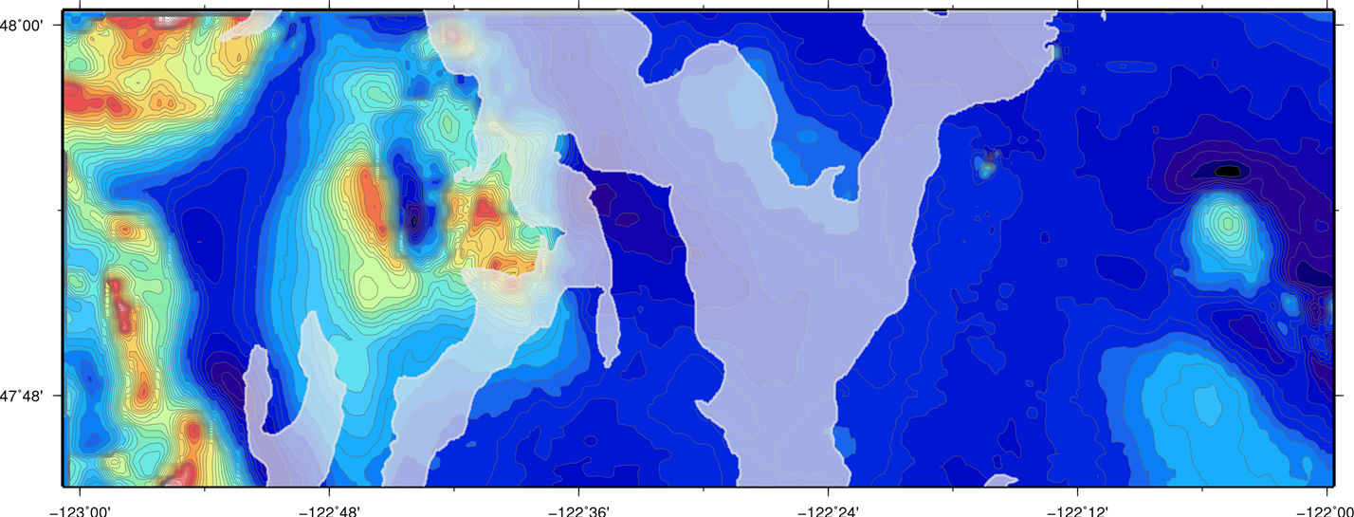Steven Rizo

Module 9

4:

Figure 1: Magnetic Map of the Seattle Quadrangle at 1:50000 scale. Gravity Values for the area range from around -400 nT (dark blue) to 1200 nT (red to white).

Figure 2: (below) Magnetic anomaly associated with the Seattle Fault Zone. Feature A is a very linear and thin magnetic anomaly. Feature B is the wide magnetic low just South of A and North of C. Feature C consists of high-amplitude, steep-gradient anomalies.

Figure 3: (bottom) Google Earth overlay of magnetic map seen in Figure 2.

